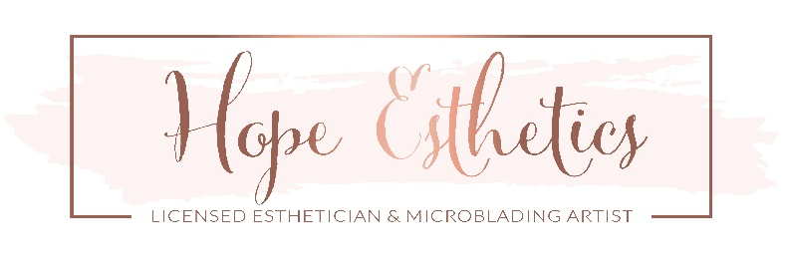
CONSENT FOR EYELASH PROCEDURE:
I have agreed to have Hope Esthetics apply eyelash extensions to and/or removed from my eyelashes. Before my qualified professional can perform this procedure, I understand I must complete this agreement and provide my informed consent by signing and dating where indicated below.
For valuable consideration, in order to have my Hope Esthetics eyelash extensions applied and/or removed from my eyelashes:
1. Waiver of Liability.
I understand there are risks associated with having artificial eyelashes applied to and/or removed from my existing eyelashes, and that notwithstanding the utmost of care in the application or removal of these products, there still exist risks associated with the procedure and product itself, which include, without limitation, eye irritation, eye pain, discomfort, and, in rare cases, blindness when improperly handled. As part of this procedure, I understand that a certain amount of eyelash adhesive material will be used to attach the artificial lashes to my existing eyelashes. Even though the Professional may apply or remove my lashes properly, I understand adhesive material may become dislodged during or after the procedure, which may irritate my eyes or require further follow-up care, at my own expense to prevent damage to my eyes. I also understand there is more than one technique for applying lashes to my eyelashes, and I will not attribute any liability to Hope Roaden or Hope Esthetics LLC as a result of this procedure or the use and care of these lashes. I also agree to defend, indemnify and hold harmless Hope Roaden and Hope Esthetics LLC from any and all claims, actions, expenses, damages and liabilities, including reasonable attorneys’ fees which might be asserted against them as a result of my having this procedure performed, or my purchase of Hope Esthetics products. As used in this agreement, the terms “Professional” and “Hope Esthetics ” include all of their respective officers, directors, agents, employees, successors and assigns.
2. Permission to Use Pictures.
I hereby grant to Professional and Hope Esthetics, LLC the full right to take, publish and reproduce photographs of me, my face, my eyes and/or eyelashes, both before and after this procedure, for any advertising, education, or other purposes whatsoever, including the right to retouch these photographs as deemed necessary by Professional or Hope Esthetics, LLC. I further expressly assign any copyright in these photographs to Hope Esthetics, LLC. I also grant my consent for Professional and Hope Esthetics, LLC to use my image and likeness as contained in these photographs for any advertising or other purposes, along with any comments I may provide. Please use these images with the following: (circle your preferred choice)
my own name no name to be used a fictitious name: ________________________________________
3. Care and Maintenance. I agree to follow the care and maintenance instructions provided by Hope Esthetics, LLC and/or Professional for the use and care of my Lashes, and that if any follow up care is required due to my own mistake or negligence, or failure to follow these instructions, this will be at my own expense and risk. I understand that if I do any of the following, it may result in damage to my lashes or may cause my lashes to fall off prematurely. Knowing this I agree to follow these tips for best results:
I will avoid oil based eye products as these will loosen the bond of my Lashes. I will avoid getting my lashes wet within the first 24 hours after my application. For the first two days after application I understand it is best to avoid swimming, saunas or steam rooms. If I experience any itching or irritation, I agree to contact my Professional immediately to have the lash extensions removed. I agree to avoid using waterproof mascara and to not use an eyelash curler, perm, or tint my Lashes. I agree to not pick, pull or rub my lashes I understand that I should not attempt to remove my lash extensions on my own or with any product, but that the procedure requires that my lash extensions be professionally removed.
4. No Known Medical Conditions / Informed Consent. I have read and completed the Client Intake Form in its entirety and in truth. I acknowledge that I have been advised of the potential harmful or negative side effects (such as the premature shedding of my eyelash) that the lash extension procedure or removal may cause to those who have specific medical or skin conditions. I understand that the adhesives and adhesive remover are a skin, eye and mucus membrane irritant and that in rare cases persons may be allergic or have hypersensitivity to synthetics, cyanoacrolate or formaldehyde which in small amount may be present in the adhesive. I understand that the procedure requires that I lay still for up to 2 hours or longer with my eyes shut, and that if I wear contacts, I must remove my contact lenses for the duration of the lash extension application or removal. I further state that I have no known medical condition that might be aggravated by the procedure or any medical condition that would prevent me from complying with or heeding to the professional’s or Lavish Lashes instructions or these warnings. If any action is brought to enforce the terms of this Agreement, the prevailing party shall be entitled to its costs and reasonable attorneys’ fees. Any claims arising out of this agreement will be resolved through binding arbitration using the rules of the American Arbitration Association. This agreement will remain in effect for this procedure, and all future procedures conducted by Professional or any other professional conducting business at the salon/spa establishment listed above.
I agree that this Agreement is binding upon me, and my heirs, legal representatives and assigns. I represent that I am over 18 years of age and that I have the right to enter this agreement, or if I am under 18 years of age, I have had my parent or legal guardian consent to this agreement, and his
or her relationship to me is as follows: _______________________________. By his or her signature below, he or she ratifies and consents to this
procedure under these terms.
Signature: ________________________________________ Print Name: ______________________ Date: _________________
Parent/Guardian Signature: __________________________ Print Name: ______________________ Date: _________________

