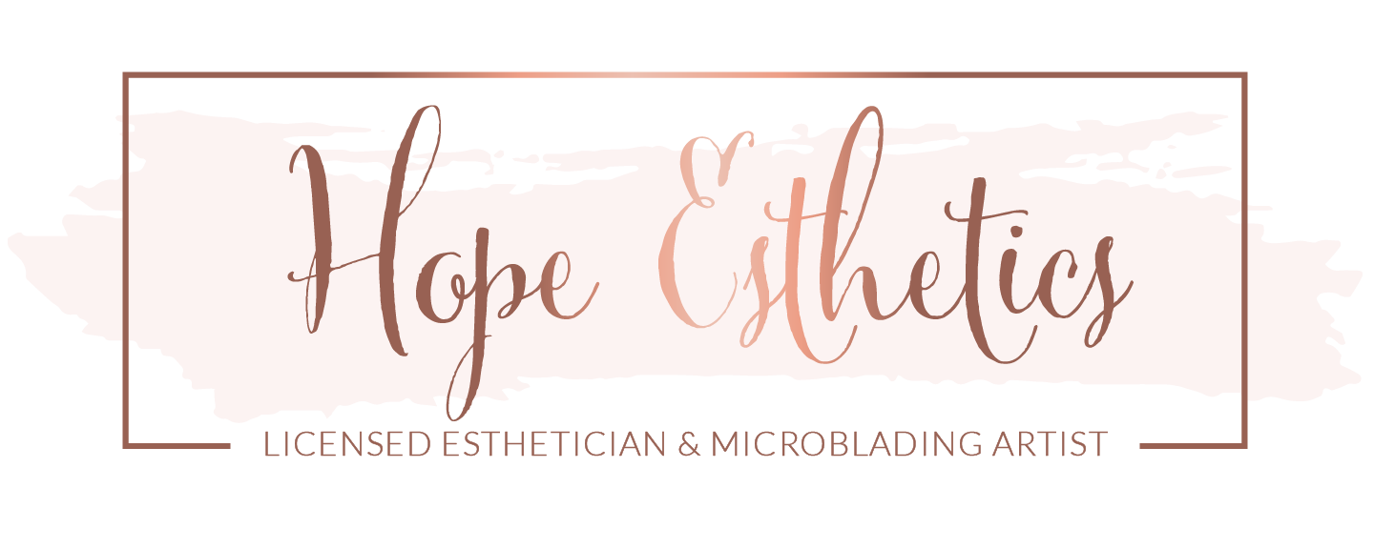
HOPE ESTHETICS TATTOO CONSENT RELEASE FORM
I acknowledge by signing this release form that I have been given the full opportunity to ask any questions I might have about obtaining a tattoo from Hope Esthetics. I acknowledge that all my questions have been answered to my full and total satisfaction. I specifically acknowledge that I have been advised of the facts and matters set forth below, and I agree as follows:
__ I am not under the influence of alcohol or drugs.
__ For the purpose of documentation and marketing, I also consent to the taking of before and after photographs/videos of said procedure which become the sole property of Hope Esthetics and may or may not be used by Hope Esthetics/ Owner of Hope Esthetics
__ I do not have acne, freckles, moles, or sunburn in the area to be tattooed that might be agitated by the tattoo process (healing excluded).
__ I have looked over my design and give my full consent to the application of my tattoo.
__ I acknowledge that I am not pregnant.
__ I acknowledge that I am free of communicable disease.
__ I acknowledge that I have truthfully represented to the associates, agents and representatives of Hope Esthetics that I am over eighteen (18) years of age.
__ I acknowledge it is not reasonably possible for the associates, agents and representatives of Hope Esthetics to determine whether I might have an allergic reaction to the dyes, pigments, or processes used in my tattoo and I agree to accept that such risks are possible.
__ I acknowledge that infection is always possible because of obtaining a tattoo particularly if I do not take proper care of my tattoo, and I have been advised of the signs and symptoms of infection that indicate a need to seek medical care.
__ I acknowledge receipt of written instructions advising me of proper care of my tattoo and recognize the absolute necessity of following those written instructions. All questions about the body art procedure have been answered to my satisfaction.
__ I acknowledge that variations in color and design may exist between any tattoos as selected by me and as ultimately applied to my body.
__ I acknowledge that tattooing is a permanent change to my appearance and that no representations have been made to me as to the ability to later change, alter or remove my tattoo.
__I acknowledge that the obtaining of my tattoo is my choice alone and I consent to the application of the tattoo and to any actions or conduct of the associates, agents or representatives of Hope Esthetics that are reasonable and necessary to perform the tattoo procedure.
__ I agree to release and forever discharge and forever hold harmless Hope Esthetics and its associates, agents’ officers and shareholders from all claims, damages, or legal actions arising from or connected in any way with my tattoo or the procedures and conduct used to apply my tattoo and all tattoos applied by Hope Esthetics and its associates, agents and representatives in the future.
__ I acknowledge that tattoo inks, dyes and pigments have not been approved by the federal Food and Drug Administration and the health consequences of using these products are unknown.
__I acknowledge that there is a chance I might feel lightheaded, dizzy during or after being tattooed. I agree to immediately notify the practitioner in the event I feel lightheaded, dizzy and/or faint before, during or after the procedure.
__ I agree to follow all instructions concerning the care of my tattoo, and that any touch-ups needed because of my own negligence will be done at my own expense.

I, (print name) ___________________ have been fully informed of the risks of tattooing including but not limited to infection, scarring, difficulties in detecting melanoma, and allergic reactions to tattoo pigment or products used. Having been informed of the potential risks associated with getting a tattoo, I still wish to proceed with tattoo application and I assume all risks that may arise from tattooing.
Signature: __________________________________________________ Date: ___________

Procedure Description: Permanent Makeup Artist: Hope Roaden/ Hope Esthetics

